Name: ____________
The Life Cycle of a Frog Investigation
Action Plan
Team Activities
Team Members: ____________ ____________ ____________ ____________
Activity | My Job | Due Date | Teacher’s Initials
Required Activity #1: Investigating the Stages of the Frog Life Cycle
Required Activity #2: Finding Out What a Frog Needs to Grow
Optional Activity #1:

Optional Activity #2:

Individual Activities
Activity | Due Date | Teacher’s Initials | 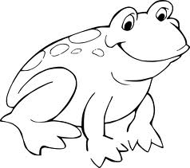
Required Activity #1: Making Observations

Required Activity #2: Creating a Vocabulary Dictionary
Optional Activity #1:

Optional Activity #2:

